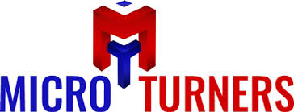
MICRO TURNERS, HARIDWAR
Subject; Regarding Campus Interview of your College
We required approximate 50 students for Production & Quality in sidcul (Haridwar).
Eligibility Criteria: Diploma Mechanical
Designation: – Trainee Engineer
Company profile: A leading Manufacturer / Supplier of leading two wheeler OEM like HERO, SKF.
We want to campus in your college so please give a time and date for campus Interview.

PARTICULAR | PER MONTH
BASIC | 3000
HRA | 1500
TRANSPORT ALLOW | 1500
MEDICAL ALLOW | 1000
EDUCATION ALLOW | 1000
OTHER ALLOW | 500
UNIFORM & WASHING ALLOW | 0
TOTAL GROSS SALARY | 8500.00
EPF As per Act. Employee Share | 395.00
ESIC As per Act. Employer | 340.00
Bonus/ Ex-gratia As per Act | 945.00
TOTAL CTC FOR 08 Hrs | 10180.00

Remark: overtime 49/hrs

